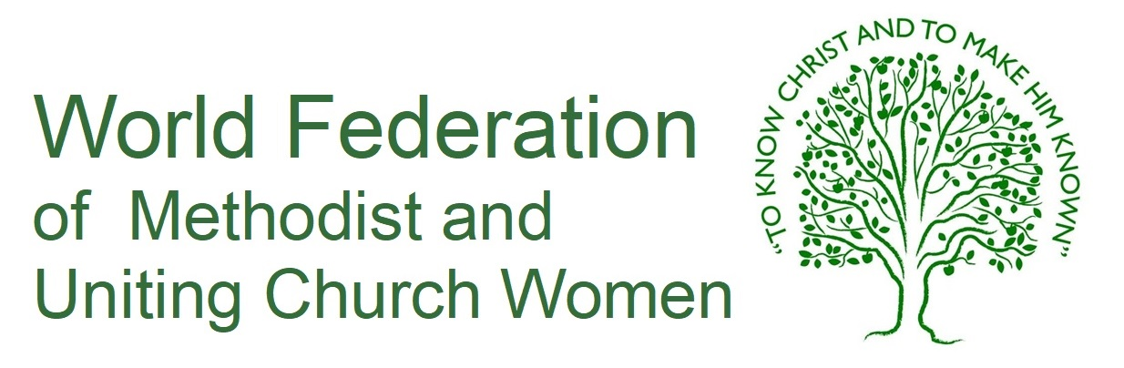

**Methodist Women in Britain invite interest for a**

**Communications Coordinator**

This is an exciting, volunteer, mainly home based opportunity, to become a full member of our Executive team as we seek to develop the organisation for the next decade.

The person appointed will ideally be a member of the Methodist Church, have good administrative and communication skills, and enjoy working as part of a team.

For information and details please contact

[thepresident.mwib@gmail.com](mailto:thepresident.mwib@gmail.com)

Closing date: 26th August 2022

Interviews: 9th September 2022