District Safeguarding Officer Report - October 2023
Workload
See review of cases
Legislative change and guidance/policies

Policy Updates and changes to the Policies and Guidance webpage

Safeguarding Policy and Procedures for the Methodist Church in Britain July 2023.
Following agreement at the recent Safeguarding Committee meeting, there is a new edition of the Safeguarding policy and procedures document - Please note the changes as listed below:

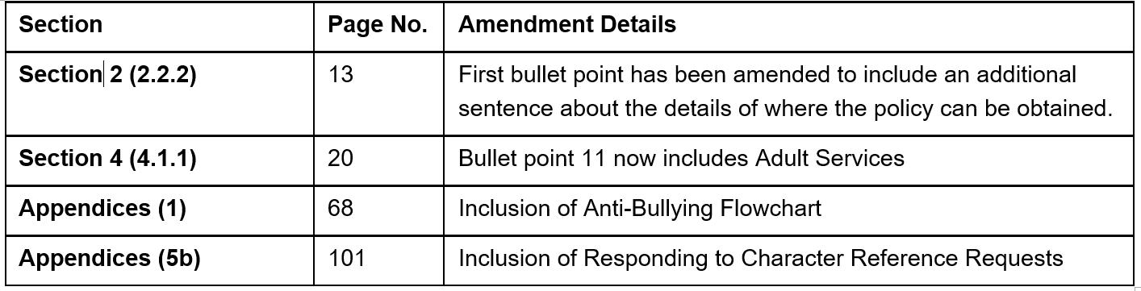

Committee members also requested an 'Executive Summary' of the most salient sections of the policy to further aid ease of access. This 10 page summary sets out the policy position of the Church and expected standards of behaviour while working with children, young people and vulnerable adults. Executive summary
Guidance for LEPs
The Committee approved the new guidance for LEPs, which is now available on the website Safeguarding Guidance for Local Ecumenical Partnerships (LEPs-July 2023
Additions to the policy and guidance page:
The following have been added to the Policies and guidance (methodist.org.uk)webpage
1) Policy and Procedures for the Methodist Church in Britain July 2023
2) Executive Summary
3) Anti-Bullying policy with additional flowchart
4) LEP guidance
Bookmarking
Some of the longer policies on the page have been bookmarked to make navigation easier.
Appendices
Some of the appendices to the main policy including the Anti-bullying policy, the LEP guidance and the Procedures for safer working practices with children have been extracted for easier reference.

