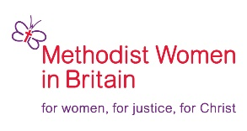

Applications are invited for:
President of Methodist Women in Britain
This is an exciting opportunity to shape the role and the future of the organisation
Is God calling you?
Application form: see attached
Closing date: Friday 5th August 2022
For further information contact: thepresident.mwib@gmail.com

The theme for the14th WFMUCW Assembly in August is :’Go and bear fruit; fruit that will last.’
We would like you to submit a presentation of a 5 to 6 minute video on the following:
As we emerge from the pandemic, what is your vision for MWiB and how can Methodist Women be encouraged to bear fruit?

